**Name: Suraj Kumar Choudhary**

**PNR: 7041**

1. **List all the running jobs**:
   * Use the command squeue to display all the jobs that are currently running.

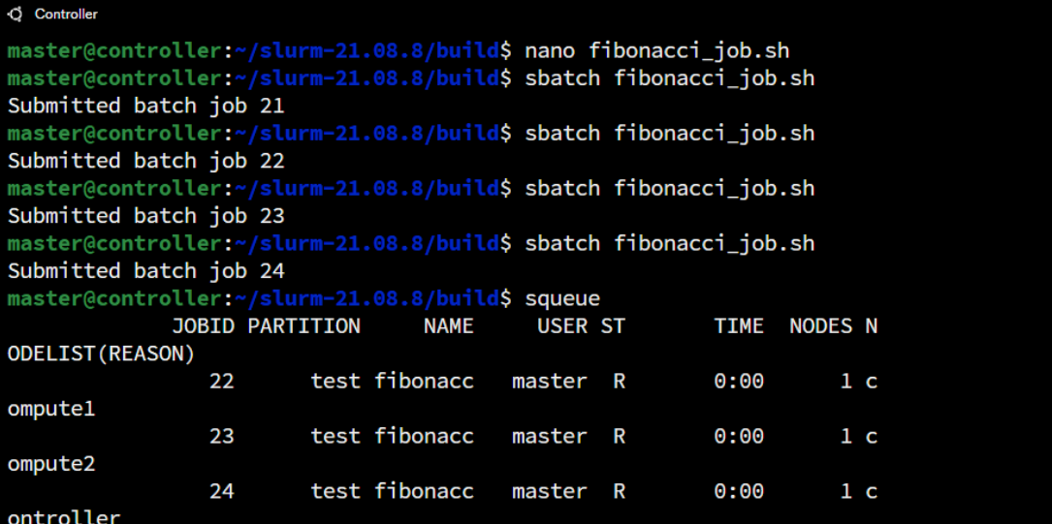

1. **List all the pending jobs**:
   * Use the command squeue with filters to show only the jobs that are waiting for resources.

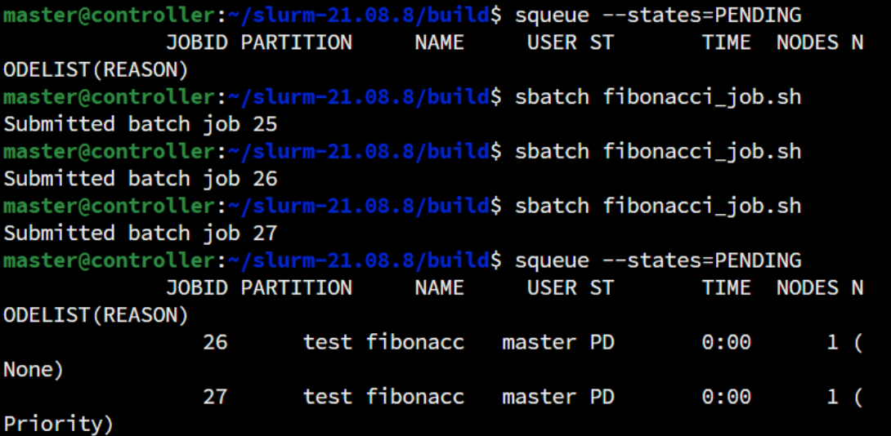

1. **List all jobs for a given user**:
   * Use the command squeue and filter it by the username to see all jobs belonging to a specific user.



1. **Cancel all pending jobs**:
   * Use the command scancel <job ID> for each pending job to cancel them. You can find the job IDs using squeue.

Screenshot 2024-12-17 005901.png